Lab 4.6.1: Basic Security Configuration (Solution)

Topology Diagram

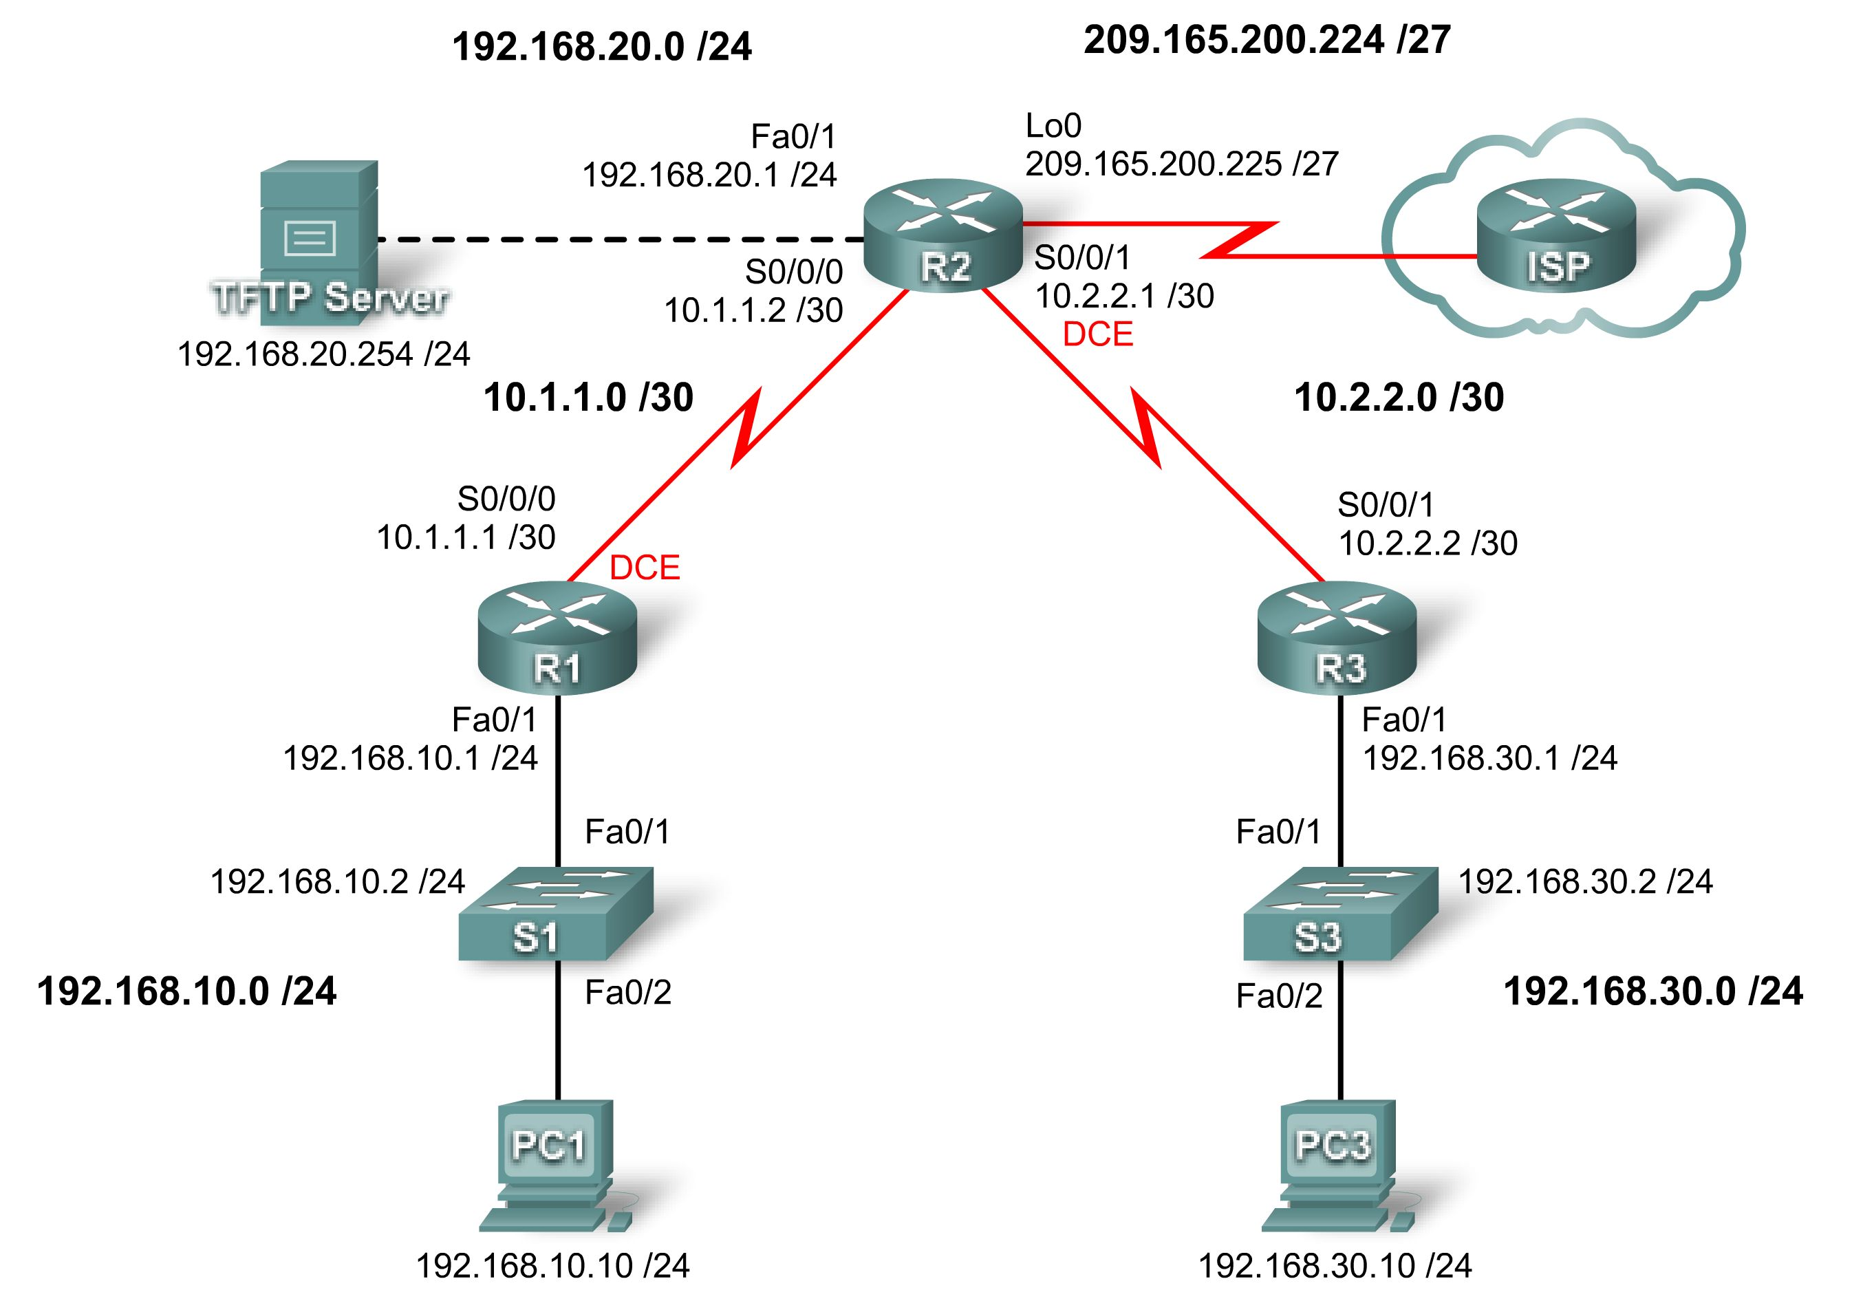

Addressing Table
Device | Interface | IP Address | Subnet Mask | Default Gateway
R1 | Fa0/1 | 192.168.10.1 | 255.255.255.0 | N/A
R1 | S0/0/0 | 10.1.1.1 | 255.255.255.252 | N/A
R2 | Fa0/1 | 192.168.20.1 | 255.255.255.0 | N/A
R2 | S0/0/0 | 10.1.1.2 | 255.255.255.252 | N/A
R2 | S0/0/1 | 10.2.2.1 | 255.255.255.252 | N/A
R2 | Lo0 | 209.165.200.225 | 255.255.255.224 | N/A
R3 | Fa0/1 | 192.168.30.1 | 255.255.255.0 | N/A
R3 | S0/0/1 | 10.2.2.2 | 255.255.255.252 | N/A
S1 | VLAN10 | 192.168.10.2 | 255.255.255.0 | N/A
S3 | VLAN20 | 192.168.30.2 | 255.255.255.0 | N/A
PC1 | NIC | 192.168.10.10 | 255.255.255.0 | 192.168.10.1
PC3 | NIC | 192.168.30.10 | 255.255.255.0 | 192.168.30.1
TFTP Server | NIC | 192.168.20.254 | 255.255.255.0 | 192.168.20.1

Learning Objectives
Upon completion of this lab, you will be able to:
- Cable a network according to the topology diagram.
- Erase the startup configuration and reload a router to the default state.
- Perform basic configuration tasks on a router.
- Configure basic router security.
- Disable unused Cisco services and interfaces.
- Protect enterprise networks from basic external and internal attacks.
- Understand and manage Cisco IOS configuration files and Cisco file system.
- Set up and use Cisco SDM (Security Device Manager) and SDM Express to configure basic router security.
- Configure VLANs on the switches.

Scenario
In this lab, you will learn how to configure basic network security using the network shown in the topology diagram. You will learn how to configure router security three different ways: using the CLI, the auto-secure feature, and Cisco SDM. You will also learn how to manage Cisco IOS software.
Task 1: Prepare the Network
Step 1: Cable a network that is similar to the one in the topology diagram.
You can use any current router in your lab as long as it has the required interfaces shown in the topology.
Note: This lab was developed and tested using 1841 routers. If you use 1700, 2500, or 2600 series routers, the router outputs and interface descriptions might be different.
Step 2: Clear any existing configurations on the routers.
Task 2: Perform Basic Router Configurations
Step 1: Configure routers.
Configure the R1, R2, and R3 routers according to the following guidelines:
- Configure the router hostname according to the topology diagram.
- Disable DNS lookup.
- Configure a message of the day banner.
- Configure IP addresses on R1, R2, and R3.
- Enable RIP version 2 on all routers for all networks.
- Create a loopback interface on R2 to simulate the connection to the Internet.
- Configure a TFTP server on PC2. If you need to download TFTP server software, one option is: http://tftpd32.jounin.net/
R1

hostname R1
no ip domain-lookup
banner motd ^Unauthorized access strictly prohibited and prosecuted to the full extent of the law.^
!
interface FastEthernet0/1
ip address 192.168.10.1 255.255.255.0
no shutdown
!
interface Serial0/0/0
ip address 10.1.1.1 255.255.255.252
no shutdown
clock rate 64000
!
router rip
version 2
network 10.0.0.0
network 192.168.10.0
no auto-summary

R2

hostname R2
no ip domain-lookup
banner motd ^Unauthorized access strictly prohibited and prosecuted to the full extent of the law.^
!
interface Loopback0
ip address 209.165.200.225 255.255.255.224
!
Interface FastEthernet0/1
ip address 192.168.20.1 255.255.255.0
no shutdown
!
interface Serial0/0/0
ip address 10.1.1.2 255.255.255.252
no shutdown
!
interface Serial0/0/1
ip address 10.2.2.1 255.255.255.252
clock rate 115200
no shutdown
!
router rip
version 2
network 10.0.0.0
network 192.168.20.0
network 209.165.200.0
no auto-summary
!

R3

hostname R3
no ip domain-lookup
banner motd ^Unauthorized access strictly prohibited and prosecuted to the full extent of the law.^
!
interface FastEthernet0/1
ip address 192.168.30.1 255.255.255.0
no shutdown
!
interface Serial0/0/1
ip address 10.2.2.2 255.255.255.252
no shutdown
!
router rip
version 2
network 10.0.0.0
network 192.168.30.0
no auto-summary
!
Step 2: Configure Ethernet interfaces.
Configure the Ethernet interfaces of PC1, PC3, and TFTP Server with the IP addresses and default gateways from the Addressing Table at the beginning of the lab.
Step 3: Test the PC configuration by pinging the default gateway from each of the PCs and the TFTP server.
Task 3: Secure the Router from Unauthorized Access
Step 1: Configure secure passwords and AAA authentication.
Use a local database on R1 to configure secure passwords. Use ciscoccna for all passwords in this lab.
R1(config)#enable secret ciscoccna

How does configuring an enable secret password help protect a router from being compromised by an attack?

The goal is to always prevent unauthorized users from accessing a device using Telnet, SSH, or via the console. If somehow hackers are able to penetrate this first layer of defense, using an enable secret password prevents them from being able to alter the configuration of the device. This provides an additional layer of security.

The username command creates a username and password that is stored locally on the router. The default privilege level of the user is 0 (the least amount of access). You can change the level of access for a user by adding the keyword privilege 0-15 before the password keyword.

R1(config)#username ccna password ciscoccna

The aaa command enables AAA (authentication, authorization, and accounting) globally on the router. This is used when connecting to the router.

R1(config)#aaa new-model

You can create an authentication list that is accessed when someone attempts to log in to the device after applying it to vty and console lines. The local keyword indicates that the user database is stored locally on the router.

R1(config)#aaa authentication login LOCAL_AUTH local

Note: LOCAL_AUTH is a case sensitive tag name that must match for all uses.

The following commands tell the router that users attempting to connect to the router should be authenticated using the list you just created.
R1(config)#line console 0
R1(config-lin)#login authentication LOCAL_AUTH
R1(config-lin)#line vty 0 4
R1(config-lin)#login authentication LOCAL_AUTH

What do you notice that is insecure about the following section of the running configuration:
R1#show run
<output omitted>
!
enable secret 5 $1$.DB7$DunHvguQH0EvLqzQCqzfr1
!
aaa new-model
!
aaa authentication login LOCAL_AUTH local
!
username ccna password 0 ciscoccna
!
<output omitted>
!
banner motd ^CUnauthorized access strictly prohibited, violators will be prosecuted to the full extent of the law^C
!
line con 0
login authentication LOCAL_AUTH
line aux 0
line vty 0 4
login authentication LOCAL_AUTH
!

The enable secret password is encrypted, but the password for the user ccna is not. This is less secure.
To apply simple encryption to the passwords, enter the following command in global config mode:
R1(config)#service password-encryption

Verify this with the show run command.

R1#show run
service password-encryption
!
enable secret 5 $1$.DB7$DunHvguQH0EvLqzQCqzfr1
!
aaa new-model
!
aaa authentication login LOCAL_AUTH local
!
username ccna password 7 0822455D0A1606141C0A
<output omitted>
!
banner motd ^CCUnauthorized access strictly prohibited, violators will be prosecuted to the full extent of the law^C
!
line con 0
login authentication LOCAL_AUTH
line aux 0
line vty 0 4
login authentication LOCAL_AUTH
!
Step 2: Secure the console and VTY lines.
You can cause the router to log out a line that has been idle for a specified time. If a network engineer was logged into a networking device and was suddenly called away, this command automatically logs the user out after the specified time. The following commands cause the line to log out after 5 minutes.

R1(config)#line console 0
R1(config-lin)#exec-timeout 5 0
R1(config-lin)#line vty 0 4
R1(config-lin)#exec-timeout 5 0

The following command hampers brute force login attempts. The router blocks login attempts for 5 minutes if someone fails two attempts within 2 minutes. This is set especially low for the purpose of this lab. An additional measure is to log each time this happens.

R1(config)#login block-for 300 attempt 2 within 120
R1(config)#security authentication failure rate 2 log

To verify this, attempt to connect to R1 from R2 via Telnet with an incorrect username and password.

On R2:

R2#telnet 10.1.1.1
Trying 10.1.1.1 ... Open
Unauthorized access strictly prohibited, violators will be prosecuted to the full extent of the law

User Access Verification

Username: cisco
Password:

% Authentication failed

User Access Verification

Username: cisco
Password:

% Authentication failed

[Connection to 10.1.1.1 closed by foreign host]
R2#telnet 10.1.1.1
Trying 10.1.1.1 ...
% Connection refused by remote host

On R1:

*Sep 10 12:40:11.211: %SEC_LOGIN-5-QUIET_MODE_OFF: Quiet Mode is OFF, because block period timed out at 12:40:11 UTC Mon Sep 10 2007
Task 4: Secure Access to the Network
Step 1: Prevent RIP routing update propagation.
Who can receive RIP updates on a network segment where RIP is enabled? Is this the most desirable setup?

Any device listening can receive RIP updates. This is not secure because it gives information about the network structure. The first step in hacking a network is network reconnaissance in which you try to map out the existing network before deciding how to attack it.
The passive-interface command prevents routers from sending routing updates to all interfaces except those interfaces configured to participate in routing updates. This command is issued as part of the RIP configuration.
The first command puts all interfaces into passive mode (the interface only receives RIP updates). The second command returns specific interfaces from passive to active mode (both sending and receiving RIP updates).
R1
R1(config)#router rip
R1(config-router)#passive-interface default
R1(config-router)#no passive-interface s0/0/0

R2
R2(config)#router rip
R2(config-router)#passive-interface default
R2(config-router)#no passive-interface s0/0/0
R2(config-router)#no passive-interface s0/0/1

R3
R3(config)#router rip
R3(config-router)#passive-interface default
R3(config-router)#no passive-interface s0/0/1
Step 2: Prevent unauthorized reception of RIP updates.
Preventing unnecessary RIP updates to the whole network is the first step to securing RIP. The next is to have RIP updates password protected. To do this, you must first configure a key to use.
R1(config)#key chain RIP_KEY
R1(config-keychain)#key 1
R1(config-keychain-key)#key-string cisco
This has to be added to each router that is going to receive RIP updates.
R2(config)#key chain RIP_KEY
R2(config-keychain)#key 1
R2(config-keychain-key)#key-string cisco
R3(config)#key chain RIP_KEY
R3(config-keychain)#key 1
R3(config-keychain-key)#key-string cisco
To use the key, each interface participating in RIP updates needs to be configured. These will be the same interfaces that were enabled using the no passive-interface command earlier.
R1
R1(config)#int s0/0/0
R1(config-if)#ip rip authentication mode md5
R1(config-if)#ip rip authentication key-chain RIP_KEY

At this point, R1 is no longer receiving RIP updates from R2, because R2 is not yet configured to use a key for routing updates. You can view this on R1 using the show ip route command and confirming that no routes from R2 appear in the routing table.
Clear out IP routes with clear ip route * or wait for routes to timeout.

R1#show ip route
Codes: C - connected, S - static, R - RIP, M - mobile, B - BGP
D - EIGRP, EX - EIGRP external, O - OSPF, IA - OSPF inter area
N1 - OSPF NSSA external type 1, N2 - OSPF NSSA external type 2
E1 - OSPF external type 1, E2 - OSPF external type 2
i - IS-IS, su - IS-IS summary, L1 - IS-IS level-1, L2 - IS-IS level-2
ia - IS-IS inter area, *- candidate default, U - per-user static route
o - ODR, P - periodic downloaded static route

Gateway of last resort is not set

10.0.0.0/8 is variably subnetted, 1 subnets, 1 masks
C 10.1.1.0/24 is directly connected, Serial0/0/0
C 192.168.10.0 is directly connected, Serial0/0/0

Configure R2 and R3 to use routing authentication. Remember that each active interface must be configured.
R2
R2(config)#int s0/0/0
R2(config-if)#ip rip authentication mode md5
R2(config-if)#ip rip authentication key-chain RIP_KEY
R2(config)#int s0/0/1
R2(config-if)#ip rip authentication mode md5
R2(config-if)#ip rip authentication key-chain RIP_KEY

R3
R3(config)#int s0/0/1
R3(config-if)#ip rip authentication mode md5
R3(config-if)#ip rip authentication key-chain RIP_KEY
Step 3: Verify that RIP routing still works.
After all three routers have been configured to use routing authentication, the routing tables should repopulate with all RIP routes. R1 should now have all the routes via RIP. Confirm this with the show ip route command.
R1#show ip route
Codes: C - connected, S - static, R - RIP, M - mobile, B - BGP
D - EIGRP, EX - EIGRP external, O - OSPF, IA - OSPF inter area
N1 - OSPF NSSA external type 1, N2 - OSPF NSSA external type 2
E1 - OSPF external type 1, E2 - OSPF external type 2
i - IS-IS, su - IS-IS summary, L1 - IS-IS level-1, L2 - IS-IS level-2
ia - IS-IS inter area, *-candidate default, U-per-user static route
o - ODR, P - periodic downloaded static route

Gateway of last resort is not set

R 192.168.30.0/24 [120/2] via 10.1.1.2, 00:00:16, Serial0/0/0
C 192.168.10.0/24 is directly connected, FastEthernet0/1
R 192.168.20.0/24 [120/1] via 10.1.1.2, 00:00:13, Serial0/0/0
10.0.0.0/8 is variably subnetted, 2 subnets, 1 masks
R 10.2.2.0/24 [120/1] via 10.1.0.2, 00:00:16, Serial0/0/0
C 10.1.1.0/24 is directly connected, Serial0/0/0

Task 5: Logging Activity with SNMP (Simple Network Management Protocol)
Step 1: Configure SNMP logging to the syslog server.
SNMP logging can be useful in monitoring network activity. The captured information can be sent to a syslog server on the network, where it can be analyzed and archived. You should be careful when configuring logging (syslog) on the router. When choosing the designated log host, remember that the log host should be connected to a trusted or protected network or an isolated and dedicated router interface.
In this lab, you will configure PC1 as the syslog server for R1. Use the logging command to select the IP address of the device to which SNMP messages are sent. In this example, the IP address of PC1 is used.
R1(config)#logging 192.168.10.10
Note: PC1 should have syslog software installed and running if you wish to view syslog messages.

In the next step, you will define the level of severity for messages to be sent to the syslog server.
Step 2: Configure the SNMP severity level.
The level of SNMP messages can be adjusted to allow the administrator to determine what kinds of messages are sent to the syslog device. Routers support different levels of logging. The eight levels range from 0 (emergencies), indicating that the system is unstable, to 7 (debugging), which sends messages that include router information. To configure the severity levels, you use the keyword associated with the level, as shown in the table.
Severity Level | Keyword | Description
0 | emergencies | System unusable
1 | alerts | Immediate action required
2 | critical | Critical conditions
3 | errors | Error conditions
4 | warnings | Warning conditions
5 | notifications | Normal but significant condition
6 | informational | Informational messages
7 | debugging | Debugging messages

The logging trap command sets the severity level. The severity level includes the level specified and anything below it (severity-wise). Set R1 to level 4 to capture messages with severity level 4, 3, 2, and 1.
R1(config)#logging trap warnings

What is the danger of setting the level of severity too high or too low?

If the level of severity is too high, the router can generate too many messages to be useful. Important messages are harder to find among less useful messages. Also it can cause network congestion. The danger in setting the level too low is that not enough information is provided when attempting to identify a problem.
Note: If you installed syslog software on PC1, generate and look at syslog software for messages.
Task 6: Disabling Unused Cisco Network Services
Step 1: Disable unused interfaces.
Why should you disable unused interfaces on network devices?

Leaving unused interfaces enabled can allow people unexpected access to the network if they gain physical access to the device. Disabling these interfaces prevents them from being used for man-in-the-middle attacks or DHCP spoofing.
In the topology diagram, you can see that R1 should only be using interface S0/0/0 and Fa0/1. All other interfaces on R1 should be administratively shut down using the shutdown interface configuration command.
R1(config)#interface fastethernet0/0
R1(config-if)#shutdown
R1(config-if)# interface s0/0/1
R1(config-if)#shutdown

*Sep 10 13:40:24.887: %LINK-5-CHANGED: Interface FastEthernet0/0, changed state to administratively down
*Sep 10 13:40:25.887: %LINEPROTO-5-UPDOWN: Line protocol on Interface FastEthernet0/0, changed state to down
To verify that R1 has all inactive interfaces shut down, use the show ip interface brief command. Interfaces manually shut down are listed as administratively down.
R1#sh ip interface brief
Interface IP-Address OK? Method Status Protocol
FastEthernet0/0 unassigned YES unset administratively down down
FastEthernet0/1 192.168.10.1 YES manual up up
Serial0/0/0 10.1.1.1 YES manual up up
Serial0/0/1 unassigned YES unset administratively down down
Step 2: Disable unused global services.
Many services are not needed in most modern networks. Leaving unused services enabled leaves ports open that can be used to compromise a network. Disable each of these services on R1.
R1(config)#no service pad
R1(config)#no service finger
R1(config)#no service udp-small-server
R1(config)#no service tcp-small-server
R1(config)#no ip bootp server
R1(config)#no ip http server
R1(config)#no ip finger
R1(config)#no ip source-route
R1(config)#no ip gratuitous-arps
R1(config)#no cdp run
Step 3: Disable unused interface services.
These commands are entered at the interface level and should be applied to every interface on R1.
R1(config-if)#no ip redirects
R1(config-if)#no ip proxy-arp
R1(config-if)#no ip unreachables
R1(config-if)#no ip directed-broadcast
R1(config-if)#no ip mask-reply
R1(config-if)#no mop enabled

Step 4: Use AutoSecure to secure a Cisco router.
By using a single command in CLI mode, the AutoSecure feature allows you to disable common IP services that can be exploited for network attacks and enable IP services and features that can aid in the defense of a network when under attack. AutoSecure simplifies the security configuration of a router and hardens the router configuration.
Using the AutoSecure feature, you can apply the same security features that you just applied (except for securing RIP) to a router much faster. Because you have already secured R1, use the auto secure command on R3.
R3#auto secure
--- AutoSecure Configuration ---

*** AutoSecure configuration enhances the security of
the router, but it will not make it absolutely resistant
to all security attacks ***

AutoSecure will modify the configuration of your device.
All configuration changes will be shown. For a detailed
explanation of how the configuration changes enhance security
and any possible side effects, please refer to Cisco.com for
Autosecure documentation.
At any prompt you may enter '?' for help.
Use ctrl-c to abort this session at any prompt.

Gathering information about the router for AutoSecure

Is this router connected to internet? [no]: yes
Enter the number of interfaces facing the internet [1]: 1

Interface IP-Address OK? Method Status Protocol
FastEthernet0/0 unassigned YES unset down down
FastEthernet0/1 192.168.30.1 YES manual up up
Serial0/0/0 unassigned YES manual down down
Serial0/0/1 10.2.2.2 YES manual up up
Enter the interface name that is facing the internet: Serial0/0/1
Securing Management plane services...

Disabling service finger
Disabling service pad
Disabling udp & tcp small servers
Enabling service password encryption
Enabling service tcp-keepalives-in
Enabling service tcp-keepalives-out
Disabling the cdp protocol

Disabling the bootp server
Disabling the http server
Disabling the finger service
Disabling source routing
Disabling gratuitous arp
Enable secret is either not configured or
Is the same as enable password
Enter the new enable password: ciscoccna
Confirm the enable password: ciscoccna
Enter the new enable password: ccnacisco
Confirm the enable password: ccnacisco

Configuration of local user database
Enter the username: ccna
Enter the password: ciscoccna
Confirm the password: ciscoccna
Configuring AAA local authentication
Configuring Console, Aux and VTY lines for
local authentication, exec-timeout, and transport
Securing device against Login Attacks
Configure the following parameters

Blocking Period when Login Attack detected: 300

Maximum Login failures with the device: 5

Maximum time period for crossing the failed login attempts: 120

Configure SSH server? Yes
Enter domain-name: cisco.com

Configuring interface specific AutoSecure services
Disabling the following ip services on all interfaces:

no ip redirects
no ip proxy-arp
no ip unreachables
no ip directed-broadcast
no ip mask-reply
Disabling mop on Ethernet interfaces

Securing Forwarding plane services...

Enabling CEF (This might impact the memory requirements for your platform)
Enabling unicast rpf on all interfaces connected to internet

Configure CBAC firewall feature: no
Tcp intercept feature is used prevent tcp syn attack
On the servers in the network. Create autosec_tcp_intercept_list
To form the list of servers to which the tcp traffic is to be observed

Enable TCP intercept feature: yes

This is the configuration generated:

no service finger
no service pad
no service udp-small-servers
no service tcp-small-servers
service password-encryption
service tcp-keepalives-in
service tcp-keepalives-out
no cdp run
no ip bootp server
no ip http server
no ip finger
no ip source-route
no ip gratuitous-arps
no ip identd
security passwords min-length 6
security authentication failure rate 10 log
enable password 7 070C285F4D061A061913
username ccna password 7 045802150C2E4F4D0718
aaa new-model
aaa authentication login local_auth local
line con 0
login authentication local_auth
exec-timeout 5 0
transport output telnet
line aux 0
login authentication local_auth
exec-timeout 10 0
transport output telnet
line vty 0 4
login authentication local_auth
transport input telnet
line tty 1
login authentication local_auth
exec-timeout 15 0
line tty 192
login authentication local_auth
exec-timeout 15 0
login block-for 300 attempts 5 within 120
service timestamps debug datetime msec localtime show-timezone
service timestamps log datetime msec localtime show-timezone
logging facility local2
logging trap debugging
service sequence-numbers
logging console critical
logging buffered
interface FastEthernet0/0
no ip redirects
no ip proxy-arp
no ip unreachables
no ip directed-broadcast
no ip mask-reply
no mop enabled
interface FastEthernet0/1
no ip redirects
no ip proxy-arp
no ip unreachables
no ip directed-broadcast
no ip mask-reply
no mop enabled
interface Serial0/0/0
no ip redirects
no ip proxy-arp
no ip unreachables
no ip directed-broadcast
no ip mask-reply
interface Serial0/0/1
no ip redirects
no ip proxy-arp
no ip unreachables
no ip directed-broadcast
no ip mask-reply
interface Serial0/1/0
no ip redirects
no ip proxy-arp
no ip unreachables
no ip directed-broadcast
no ip mask-reply
interface Serial0/1/1
no ip redirects
no ip proxy-arp
no ip unreachables
no ip directed-broadcast
no ip mask-reply
ip cef
access-list 100 permit udp any any eq bootpc
interface Serial0/0/1
ip verify unicast source reachable-via rx allow-default 100
ip tcp intercept list autosec_tcp_intercept_list
ip tcp intercept drop-mode random
ip tcp intercept watch-timeout 15
ip tcp intercept connection-timeout 3600
ip tcp intercept max-incomplete low 450
ip tcp intercept max-incomplete high 550
!
end

Apply this configuration to running-config? [yes]:yes

The name for the keys will be: R3.cisco.com

% The key modulus size is 1024 bits
% Generating 1024 bit RSA keys, keys will be non-exportable...[OK]
R3#
000045: *Nov 16 15:39:10.991 UTC: %AUTOSEC-1-MODIFIED: AutoSecure configuration has been Modified on this device

As you can see, the AutoSecure feature is much faster than line by line configuration. However, there are advantages to doing it manually, as you will see in the troubleshooting lab. When you use AutoSecure, you may disable a service you need. Always use caution and think about the services that you require before using AutoSecure.
Task 7: Managing Cisco IOS and Configuration Files
Step 1: Show Cisco IOS files.
Cisco IOS is the software that routers use to operate. Your router may have enough memory to store multiple Cisco IOS images. It is important to know which files are stored on your router.
Issue the show flash command to view the contents of the flash memory of your router.
Caution: Be very careful when issuing commands that involve the flash memory. Mistyping a command could result in the deletion of the Cisco IOS image.
R2#show flash
-#- --length-- -----date/time------ path
1 13937472 May 05 2007 21:25:14 +00:00 c1841-ipbase-mz.124-1c.bin
2 1821 May 05 2007 21:40:28 +00:00 sdmconfig-18xx.cfg
3 4734464 May 05 2007 21:41:02 +00:00 sdm.tar
4 833024 May 05 2007 21:41:24 +00:00 es.tar
5 1052160 May 05 2007 21:41:48 +00:00 common.tar

8679424 bytes available (23252992 bytes used)

Just by looking at this list, we can determine the following:
- The image is for an 1841 router (c1841-ipbase-mz.124-1c.bin).
- The router is using IP base image (c1841-ipbase-mz.124-1c.bin).
- The Cisco IOS is version 12.4(1c) (c1841-ipbase-mz.124-1c.bin).
- SDM is installed on this device (sdmconfig-18xx.cfg, sdm.tar).
You can use the dir all command to show all files on the router.
R1#dir all
Directory of archive:/

No files in directory

No space information available
Directory of system:/

3 dr-x 0 <no date> memory
1 -rw- 979 <no date> running-config
2 dr-x 0 <no date> vfiles

No space information available
Directory of nvram:/

189 -rw- 979 <no date> startup-config
190 ---- 5 <no date> private-config
191 -rw- 979 <no date> underlying-config
1 -rw- 0 <no date> ifIndex-table

196600 bytes total (194540 bytes free)
Directory of flash:/

1 -rw- 13937472 May 05 2007 20:08:50 +00:00 c1841-ipbase-mz.124-1c.bin
2 -rw- 1821 May 05 2007 20:25:00 +00:00 sdmconfig-18xx.cfg
3 -rw- 4734464 May 05 2007 20:25:38 +00:00 sdm.tar
4 -rw- 833024 May 05 2007 20:26:02 +00:00 es.tar
5 -rw- 1052160 May 05 2007 20:26:30 +00:00 common.tar
6 -rw- 1038 May 05 2007 20:26:56 +00:00 home.shtml
7 -rw- 102400 May 05 2007 20:27:20 +00:00 home.tar
8 -rw- 491213 May 05 2007 20:27:50 +00:00 128MB.sdf
9 –rw- 398305 May 05 2007 20:29:08 +00:00 sslclient-win-1.1.0.154.pkg
10 -rw- 1684577 May 05 2007 20:28:32 +00:00 securedesktop-ios-3.1.1.27-k9.pkg

31932416 bytes total (8679424 bytes free)
Step 2: Transfer files with TFTP.
TFTP is used when archiving and updating the Cisco IOS software of a device. In this lab, however, we do not use actual Cisco IOS files because any mistakes made in entering the commands could lead to erasing the Cisco IOS image of the device. At the end of this section, there is an example of what a Cisco IOS TFTP transfer looks like.
Why is it important to have an updated version of Cisco IOS software?

The software might be updated to fix a bug or to replace a release that is no longer supported. Having an updated version ensures that the latest security fixes are included in the running Cisco IOS software.
When transferring files via TFTP, it is important to ensure that the TFTP server and the router can communicate. One way to test this is to ping between these devices.
To begin transfer of the Cisco IOS software, create a file on the TFTP server called test in the TFTP root folder. Each TFTP program differs in where files are stored. Consult your TFTP server help file to determine the root folder.
From R1, retrieve the file and save it to the flash memory.
R1#copy tftp flash
Address or name of remote host []? 192.168.20.254 (IP address of the TFTP server)
Source filename []? Test (name of the file you created and saved to TFTP server)
Destination filename [test]? test-server (An arbitrary name for the file when saved to the router)
Accessing tftp://192.168.20.254/test...
Loading test from 192.168.20.254 (via FastEthernet0/1): !
[OK - 1192 bytes]

1192 bytes copied in 0.424 secs (2811 bytes/sec)

Verify the file’s existence in the flash with the show flash command.
R1#show flash
-#- --length-- -----date/time------ path
1 13937472 May 05 2007 21:13:20 +00:00 c1841-ipbase-mz.124-1c.bin
2 1821 May 05 2007 21:29:36 +00:00 sdmconfig-18xx.cfg
3 4734464 May 05 2007 21:30:14 +00:00 sdm.tar
4 833024 May 05 2007 21:30:42 +00:00 es.tar
5 1052160 May 05 2007 21:31:10 +00:00 common.tar
6 1038 May 05 2007 21:31:36 +00:00 home.shtml
7 102400 May 05 2007 21:32:02 +00:00 home.tar
8 491213 May 05 2007 21:32:30 +00:00 128MB.sdf
9 1684577 May 05 2007 21:33:16 +00:00 securedesktop-ios-3.1.1.27-k9.pkg
10 398305 May 05 2007 21:33:50 +00:00 sslclient-win-1.1.0.154.pkg
11 1192 Sep 12 2007 07:38:18 +00:00 test-server

8675328 bytes available (23257088 bytes used)

Routers can also act as TFTP servers. This can be useful if there is a device that needs an image and you have one that is already using that image. We will make R2 a TFTP server for R1. Remember that Cisco IOS images are specific to router platforms and memory requirements. Use caution when transferring a Cisco IOS image from one router to another.
The command syntax is: tftp-server nvram: [filename1 [alias filename2]
The command below configures R2 as a TFTP server. R2 supplies its startup config file to devices requesting it via TFTP (we are using the startup config for the sake of simplicity and ease). The alias keyword allows devices to request the file using the alias test instead of the full filename.
R1(config)#tftp-server nvram:startup-config alias test

Now we can request the file from R2 using R1.
R1#copy tftp flash
Address or name of remote host []? 10.1.1.2
Source filename []? test
Destination filename []? test-router
Accessing tftp://10.1.1.2/test...
Loading test from 10.1.1.2 (via Serial0/0/0): !
[OK - 1192 bytes]

1192 bytes copied in 0.452 secs (2637 bytes/sec)

Again, verify that the file test has been successfully copied with the show flash command
R1#show flash
-#- --length-- -----date/time------ path
1 13937472 May 05 2007 21:13:20 +00:00 c1841-ipbase-mz.124-1c.bin
2 1821 May 05 2007 21:29:36 +00:00 sdmconfig-18xx.cfg
3 4734464 May 05 2007 21:30:14 +00:00 sdm.tar
4 833024 May 05 2007 21:30:42 +00:00 es.tar
5 1052160 May 05 2007 21:31:10 +00:00 common.tar
6 1038 May 05 2007 21:31:36 +00:00 home.shtml
7 102400 May 05 2007 21:32:02 +00:00 home.tar
8 491213 May 05 2007 21:32:30 +00:00 128MB.sdf
9 1684577 May 05 2007 21:33:16 +00:00 securedesktop-ios-3.1.1.27-k9.pkg
10 398305 May 05 2007 21:33:50 +00:00 sslclient-win-1.1.0.154.pkg
11 1192 Sep 12 2007 07:38:18 +00:00 test-server
12 1192 Sep 12 2007 07:51:04 +00:00 test-router

8671232 bytes available (23261184 bytes used)

Because you do not want unused files occupying precious memory space, delete them now from the flash memory of R1. Be very careful when doing this! Accidentally erasing flash memory will mean that you have to re-install the entire IOS image for the router. If the router prompts you to erase flash, something is very wrong. You rarely want to erase the entire flash. The only legitimate time this will happen is when you are upgrading the IOS to a large IOS image. If you see the erase flash prompt as in the example, STOP IMMEDIATELY. Do NOT hit enter. IMMEDIATELY ask for assistance from your instructor.
Erase flash: ?[confirm] no

R1#delete flash:test-server
Delete filename [test-server]?
Delete flash:test? [confirm]
R1#delete flash:test-router
Delete filename [test-router]?
Delete flash:test-router? [confirm]

Verify that the files have been deleted by issuing the show flash command.
R1#show flash
-#- --length-- -----date/time------ path
1 13937472 May 05 2007 21:13:20 +00:00 c1841-ipbase-mz.124-1c.bin
2 1821 May 05 2007 21:29:36 +00:00 sdmconfig-18xx.cfg
3 4734464 May 05 2007 21:30:14 +00:00 sdm.tar
4 833024 May 05 2007 21:30:42 +00:00 es.tar
5 1052160 May 05 2007 21:31:10 +00:00 common.tar
6 1038 May 05 2007 21:31:36 +00:00 home.shtml
7 102400 May 05 2007 21:32:02 +00:00 home.tar
8 491213 May 05 2007 21:32:30 +00:00 128MB.sdf
9 1684577 May 05 2007 21:33:16 +00:00 securedesktop-ios-3.1.1.27-k9.pkg
10 398305 May 05 2007 21:33:50 +00:00 sslclient-win-1.1.0.154.pkg

8679424 bytes available (23252992 bytes used)

The following is an example of a TFTP transfer of a Cisco IOS image file.
Do NOT complete on your routers. Only read it.

R1#copy tftp flash
Address or name of remote host []? 10.1.1.2
Source filename []? c1841-ipbase-mz.124-1c.bin
Destination filename []? flash:c1841-ipbase-mz.124-1c.bin
Accessing tftp://10.1.1.2/c1841-ipbase-mz.124-1c.bin...
Loading c1841-ipbase-mz.124-1c.bin from 10.1.1.2 (via Serial0/0/0): !!!!!!!!!!!!!!!!!!!!!!!!!!!!!!!!!!!!!!!!!!!!!!!!!!!!!!!!!!!!!!!!!!!!!!!!!!!!!
<output omitted>
!!!!!!!!!!!!!!!!!!!!!!!!!!!!
[OK - 13937472 bytes]

13937472 bytes copied in 1113.948 secs (12512 bytes/sec)
Step 3: Recover a password using ROMmon.
If for some reason you can no longer access a device because you do not know, have lost, or have forgotten a password, you can still gain access by changing the configuration register. The configuration register tells the router which configuration to load on bootup. In the configuration register, you can instruct the router to boot from a blank configuration that is not password protected.
The first step in changing the configuration register is to view the current setting using the show version command. These steps are performed on R3.
R3#show version
Cisco IOS Software, 1841 Software (C1841-IPBASE-M), Version 12.4(1c), RELEASE SOFTWARE (fc1)
Technical Support: http://www.cisco.com/techsupport
Copyright (c) 1986-2005 by Cisco Systems, Inc.
Compiled Tue 25-Oct-05 17:10 by evmiller

ROM: System Bootstrap, Version 12.4(13r)T, RELEASE SOFTWARE (fc1)

R3 uptime is 25 minutes
System returned to ROM by reload at 08:56:50 UTC Wed Sep 12 2007
System image file is "flash:c1841-ipbase-mz.124-1c.bin"

Cisco 1841 (revision 7.0) with 114688K/16384K bytes of memory.
Processor board ID FTX1118X0BN
2 FastEthernet interfaces
2 Low-speed serial(sync/async) interfaces
DRAM configuration is 64 bits wide with parity disabled.
191K bytes of NVRAM.
31360K bytes of ATA CompactFlash (Read/Write)

Configuration register is 0x2102

Next, reload the router and send a break during the boot up. The Break key is different on different computers. Frequently, it is in the upper right hand corner of the keyboard. A break causes the device to enter a mode called ROMmon. This mode does not require the device to have access to a Cisco IOS image file.
Note: Hyperterminal requires a Ctrl-Break sequence. For other terminal emulation software, check the standard Break Key sequence combinations.

R3#reload
Proceed with reload? [confirm]

*Sep 12 08:27:28.670: %SYS-5-RELOAD: Reload requested by console. Reload Reason: Reload command.
System Bootstrap, Version 12.4(13r)T, RELEASE SOFTWARE (fc1)
Technical Support: http://www.cisco.com/techsupport
Copyright (c) 2006 by cisco Systems, Inc.
PLD version 0x10
GIO ASIC version 0x127
c1841 platform with 131072 Kbytes of main memory
Main memory is configured to 64 bit mode with parity disabled

Readonly ROMMON initialized
rommon 1 >

Change the configuration register to a value that loads the initial configuration of the router. This configuration does not have a password configured, but supports Cisco IOS commands. Change the value of the configuration register to 0x2142.
rommon 1 > confreg 0x2142
Now that this is changed we can boot the device with the reset command.
rommon 2 > reset
program load complete, entry point: 0x8000f000, size: 0xcb80
program load complete, entry point: 0x8000f000, size: 0xcb80

program load complete, entry point: 0x8000f000, size: 0xd4a9a0
Self decompressing the image : ###########################################################
############################################################################## [OK]

<output omitted>

--- System Configuration Dialog ---

Would you like to enter the initial configuration dialog? [yes/no]: no

Press RETURN to get started!
Step 4: Restore the router.
Now we copy the startup configuration to the running configuration, restore the configuration, and then change the configuration register back to the default (0x2102).
To copy the startup configuration from NVRAM to running memory, type copy startup-config running-config. Be careful! Do not type copy running-config startup-config or you will erase your startup configuration.
Router#copy startup-config running-config
Destination filename [running-config]? {enter}

2261 bytes copied in 0.576 secs (3925 bytes/sec)

R3#:show running-config
<output omitted>
enable secret 5 $1$31P/$cyPgoxc0R9y93Ps/N3/kg.
!
<output omitted>
!
key chain RIP_KEY
key 1
key-string 7 01100F175804
username ccna password 7 094F471A1A0A1411050D
!
interface FastEthernet0/1
ip address 192.168.30.1 255.255.255.0
no ip redirects
no ip unreachables
no ip proxy-arp
no ip directed-broadcast
shutdown
duplex auto
speed auto
!
interface Serial0/0/1
ip address 10.2.2.2 255.255.255.252
no ip redirects
no ip unreachables
no ip proxy-arp
no ip directed-broadcast
shutdown
ip rip authentication mode md5
ip rip authentication key-chain RIP_KEY
!
<output omitted>
!
line con 0
exec-timeout 5 0
logging synchronous
login authentication
transport output telnet
line aux 0
exec-timeout 15 0
logging synchronous
login authentication local_auth
transport output telnet
line vty 0 4
exec-timeout 15 0
logging synchronous
login authentication local_auth
transport input telnet
!
end
In this configuration, the shutdown command appears under all interfaces because all the interfaces are currently shut down. Most important, you can now see the passwords (enable password, enable secret, VTY, console passwords) in either an encrypted or unencrypted format. You can reuse unencrypted passwords. You must change encrypted passwords to a new password.
R3#configure terminal
Enter configuration commands, one per line. End with CNTL/Z.
R3(config)#enable secret ciscoccna
R3(config)#username ccna password ciscoccna
Issue the no shutdown command on every interface that you want to use.
R3(config)#interface FastEthernet0/1
R3(config-if)#no shutdown
R3(config)#interface Serial0/0/1
R3(config-if)#no shutdown
You can issue a show ip interface brief command to confirm that your interface configuration is correct. Every interface that you want to use should display up up.
R3#show ip interface brief
Interface IP-Address OK? Method Status Protocol
FastEthernet0/0 unassigned YES NVRAM administratively down down
FastEthernet0/1 192.168.30.1 YES NVRAM up up
Serial0/0/1 unassigned YES NVRAM administratively down down
Serial0/0/0 10.2.2.2 YES NVRAM up up
Type config-register configuration register value. The variable configuration register value is either the value you recorded in Step 3 or 0x2102. Save the running configuration.
R3(config)#config-register 0x2102
R3(config)#end
R3#copy running-config startup-config
Destination filename [startup-config]?
Building configuration...
[OK]
What are the downsides to password recovery?

First, if your passwords are encrypted, you cannot see them or recover them. This is why you should always have a backup of all working configurations for devices in a production network. The second drawback is that anyone with physical access to a device can follow these steps and take control of a device. Therefore, physical security for network devices is essential.
Configs for Part 1
R1
!
no service pad
service timestamps debug datetime msec
service timestamps log datetime msec
service password-encryption
!
hostname R1
!
security authentication failure rate 5 log
enable secret 5 $1$0Ch/$fp.BLSjtqOwxL7VyBwURB1
!
aaa new-model
!
aaa authentication login LOCAL_AUTH local
!
aaa session-id common
!
resource policy
!
memory-size iomem 10
no ip source-route
no ip gratuitous-arps
!
no ip bootp server
no ip domain lookup
login block-for 300 attempts 2 within 120
!
!
key chain RIP_KEY
key 1
key-string 7 05080F1C2243
!
username ccna password 7 070C285F4D061A061913
!
interface FastEthernet0/0
no ip address
no ip redirects
no ip unreachables
no ip proxy-arp
shutdown
duplex auto
speed auto
no mop enabled
!
interface FastEthernet0/1
ip address 192.168.10.1 255.255.255.0
no ip redirects
no ip unreachables
no ip proxy-arp
duplex auto
speed auto
no mop enabled
!
interface Serial0/0/0
ip address 10.1.1.1 255.255.255.252
no ip redirects
no ip unreachables
no ip proxy-arp
ip rip authentication mode md5
ip rip authentication key-chain RIP_KEY
clock rate 64000
!
interface Serial0/0/1
no ip address
no ip redirects
no ip unreachables
no ip proxy-arp
shutdown
!
router rip
version 2
passive-interface default
no passive-interface Serial0/0/0
network 10.0.0.0
network 192.168.10.0
no auto-summary
!
no ip http server
no ip http secure-server
!
logging trap warnings
logging 192.168.10.10
no cdp run
!
banner motd ^CUnauthorized access strictly prohibited and prosecuted to the full extent of the law.^C
!
line con 0
exec-timeout 5 0
login authentication LOCAL_AUTH
line aux 0
line vty 0 4
exec-timeout 5 0
login authentication LOCAL_AUTH
!
scheduler allocate 20000 1000
!
end

R2
hostname R2
!
no ip domain lookup
!
key chain RIP_KEY
key 1
key-string cisco
!
interface Loopback0
ip address 209.165.200.225 255.255.255.224
!
interface FastEthernet0/0
no ip address
shutdown
duplex auto
speed auto
!
interface FastEthernet0/1
ip address 192.168.20.1 255.255.255.0
duplex auto
speed auto
!
interface Serial0/0/0
ip address 10.1.1.2 255.255.255.252
ip rip authentication mode md5
ip rip authentication key-chain RIP_KEY
!
interface Serial0/0/1
ip address 10.2.2.1 255.255.255.252
ip rip authentication mode md5
ip rip authentication key-chain RIP_KEY
clock rate 115200
!
router rip
version 2
passive-interface default
no passive-interface Serial0/0/0
no passive-interface Serial0/0/1
network 10.0.0.0
network 192.168.20.0
network 209.165.200.0
no auto-summary
!
no ip http server
no ip http secure-server
!
banner motd ^CUnauthorized access strictly prohibited and prosecuted to the full extent of the law.^C
!
line con 0
line aux 0
line vty 0 4
login
!
end

R3
no service pad
service tcp-keepalives-in
service tcp-keepalives-out
service timestamps debug datetime msec localtime show-timezone
service timestamps log datetime msec localtime show-timezone
service password-encryption
service sequence-numbers
!
hostname R3
!
security authentication failure rate 10 log
security passwords min-length 6
logging buffered 4096 debugging
logging console critical
enable secret 5 $1$ZT.e$0rWCK4DgdK5sz7tThM16S0
enable password 7 141411050D0723382727
!
aaa new-model
!
aaa authentication login local_auth local
!
aaa session-id common
!
no ip source-route
no ip gratuitous-arps
ip tcp intercept list autosec_tcp_intercept_list
ip tcp intercept connection-timeout 3600
ip tcp intercept watch-timeout 15
ip tcp intercept max-incomplete low 450
ip tcp intercept max-incomplete high 550
ip tcp intercept drop-mode random
!
no ip bootp server
no ip domain lookup
ip domain name cisco.com
ip ssh time-out 60
ip ssh authentication-retries 2
login block-for 300 attempts 5 within 120
!
key chain RIP_KEY
key 1
key-string 7 05080F1C2243
!
username ccna password 7 070C285F4D061A061913
archive
log config
logging enable
!
interface FastEthernet0/0
no ip address
no ip redirects
no ip unreachables
no ip proxy-arp
shutdown
duplex auto
speed auto
no mop enabled
!
interface FastEthernet0/1
ip address 192.168.30.1 255.255.255.0
no ip redirects
no ip unreachables
no ip proxy-arp
duplex auto
speed auto
no mop enabled
!
interface Serial0/0/0
no ip address
no ip redirects
no ip unreachables
no ip proxy-arp
shutdown
clock rate 2000000
!
interface Serial0/0/1
ip address 10.2.2.2 255.255.255.252
ip verify unicast source reachable-via rx allow-default 100
no ip redirects
no ip unreachables
no ip proxy-arp
ip rip authentication mode md5
ip rip authentication key-chain RIP_KEY
!
interface Serial0/1/0
no ip address
no ip redirects
no ip unreachables
no ip proxy-arp
shutdown
clock rate 2000000
!
interface Serial0/1/1
no ip address
no ip redirects
no ip unreachables
no ip proxy-arp
shutdown
clock rate 2000000
!
router rip
version 2
passive-interface default
no passive-interface Serial0/0/1
network 10.0.0.0
network 192.168.30.0
no auto-summary
!
no ip http server
no ip http secure-server
!
logging trap debugging
logging facility local2
access-list 100 permit udp any any eq bootpc
no cdp run
!
banner motd ^CUnauthorized access strictly prohibited and prosecuted to the full extent of the law.^C
!
line con 0
exec-timeout 5 0
login authentication local_auth
transport output telnet
line aux 0
exec-timeout 15 0
login authentication local_auth
transport output telnet
line vty 0 4
login authentication local_auth
transport input telnet ssh
!
scheduler allocate 20000 1000
!
end
Task 8: Using SDM to Secure a Router
If SDM is not installed on the routers, please refer to the Appendix “How to Install SDM” for directions on how to install SDM. These directions are not included in the student version of this lab.

In this task, you will use Security Device Manager (SDM), the GUI interface, to secure router R2. SDM is faster than typing each command and gives you more control than the AutoSecure feature.
Verify whether SDM is installed on your router:
R2#show flash
-#- --length-- -----date/time------ path
1 13937472 Sep 12 2007 08:31:42 +00:00 c1841-ipbase-mz.124-1c.bin
2 1821 May 05 2007 21:29:36 +00:00 sdmconfig-18xx.cfg
3 4734464 May 05 2007 21:30:14 +00:00 sdm.tar
4 833024 May 05 2007 21:30:42 +00:00 es.tar
5 1052160 May 05 2007 21:31:10 +00:00 common.tar
6 1038 May 05 2007 21:31:36 +00:00 home.shtml
7 102400 May 05 2007 21:32:02 +00:00 home.tar
8 491213 May 05 2007 21:32:30 +00:00 128MB.sdf
9 1684577 May 05 2007 21:33:16 +00:00 securedesktop-ios-3.1.1.27-k9.pkg
10 398305 May 05 2007 21:33:50 +00:00 sslclient-win-1.1.0.154.pkg
11 2261 Sep 25 2007 23:20:16 +00:00 Tr(RIP)
12 2506 Sep 26 2007 17:11:58 +00:00 save.txt

If SDM is NOT installed on your router, it must be installed to continue. Please consult your instructor for directions.
Step 1: Connect to R2 using TFTP Server.
Create a username and password on R2.
R2(config)#username ccna password ciscoccna
Enable the http secure server on R2 and connect to R2 using a web browser on TFTP Server.
R2(config)#ip http secure-server
% Generating 1024 bit RSA keys, keys will be non-exportable...[OK]
R2(config)#
*Nov 16 16:01:07.763: %SSH-5-ENABLED: SSH 1.99 has been enabled
*Nov 16 16:01:08.731: %PKI-4-NOAUTOSAVE: Configuration was modified. Issue "write memory" to save new certificate
R2(config)#end
R2#copy run start

From TFTP Server, open a web browser and navigate to https://192.168.20.1/. Login with the previously configured username and password:
username: ccna
password: ciscoccna
Select Cisco Router and Security Device Manager
Open Internet Explorer and enter the IP address for R2 in the address bar. A new window opens. Make sure that you have all popup blockers turned off in your browser. Also make sure that JAVA is installed and updated.
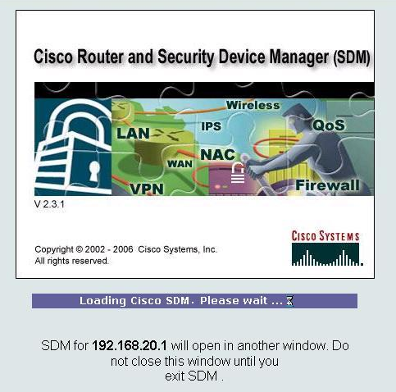
After it is done loading, a new window opens for SDM.
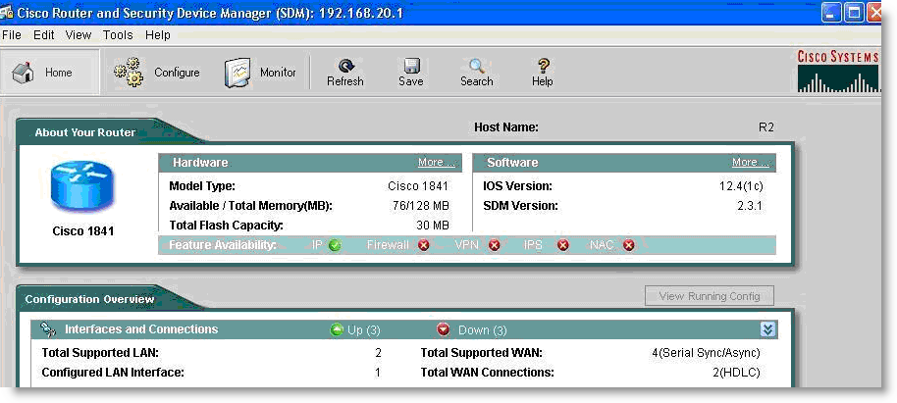
Step 2: Navigate to the Security Audit feature.
Click the Configure button in the top left side of the window.
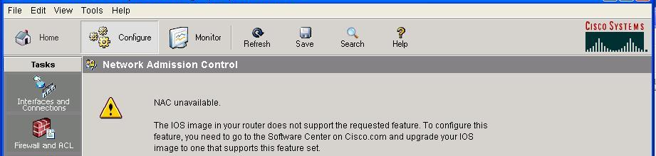
Now navigate down the left panel to Security Audit and click on it.
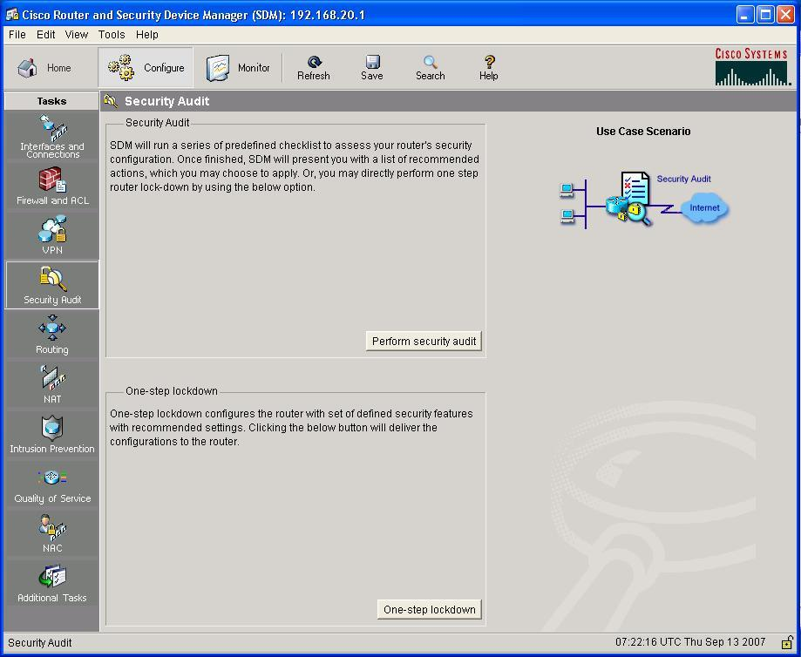
When you click on Security Audit, another window opens.
Step 3: Perform a Security Audit.
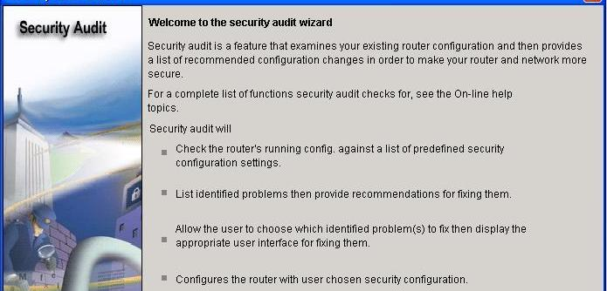
This gives a brief explanation of what the Security Audit feature does. Click on Next to open the Security Audit Interface configuration window.
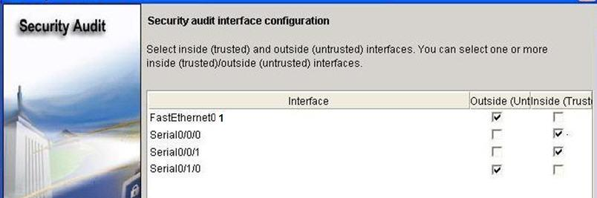
An interface should be classified as outside (untrusted) if you cannot be sure of the legitimacy of the traffic coming into the interface. In this example, both FastEthernet0/1 and Serial0/1/0 are untrusted because Serial0/1/0 is facing the Internet, and Fastethernet0/1 is facing the access part of the network and illegitimate traffic could be generated.
After selecting outside and inside interfaces, click Next. A new window opens indicating that SDM is conducting a security audit.
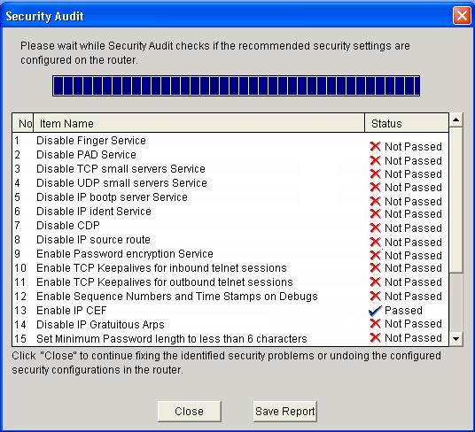
As you can see, the default configuration is unsecure. Click the Close button to continue.
Step 4: Apply settings to the router.
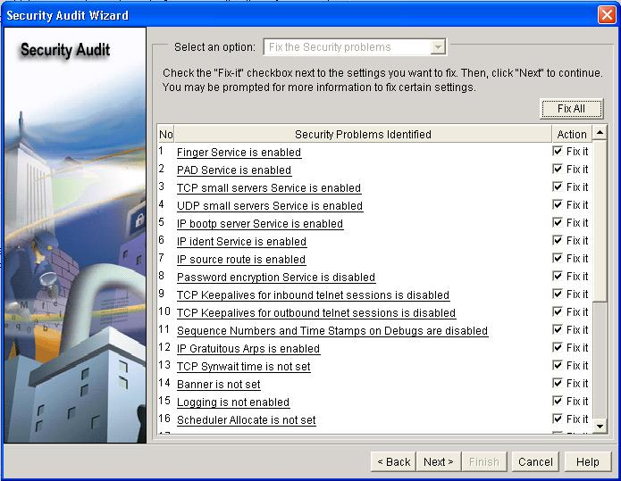
Click the Fix All button to make all the suggested security changes. Then click the Next button.
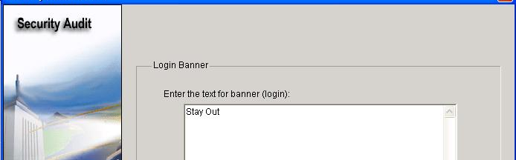
Enter a banner message to use as the message of the day for the router, and then click Next.
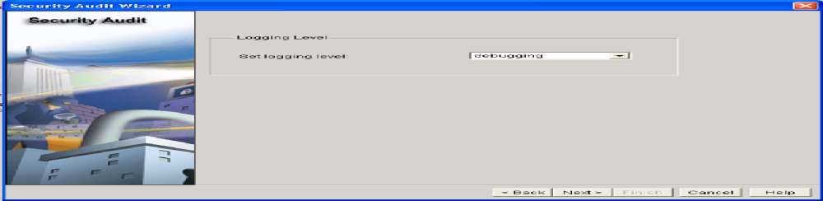
Next, set the level of severity of log traps that you want the router to send to the syslog server. The severity level is set to debugging for this scenario. Click Next to view a summary of the changes about to be made to the router.
Step 5: Commit the configuration to the router.
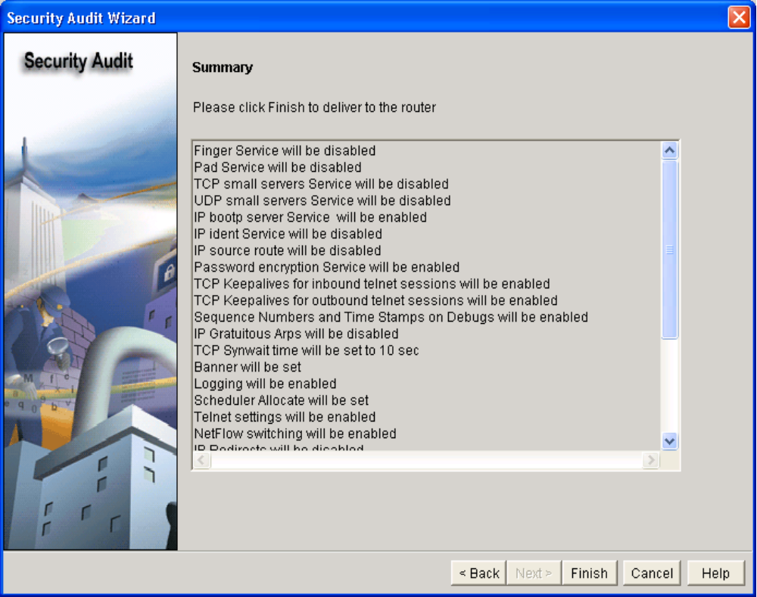
After reviewing the changes about to be committed, click Finish.
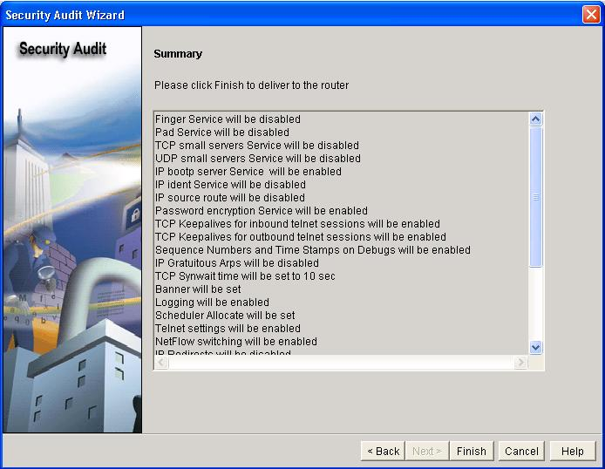
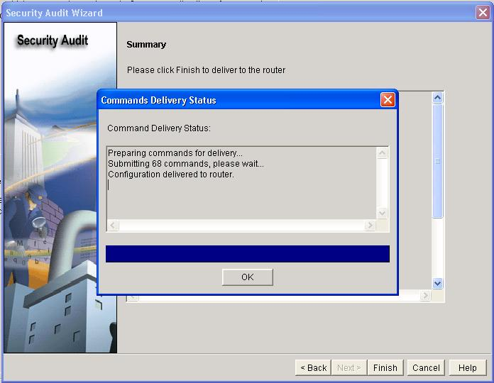
Click OK and exit SDM.
Task 9: Document the Router Configurations
On each router, issue the show run command and capture the configurations.
R1
!
no service pad
service timestamps debug datetime msec
service timestamps log datetime msec
service password-encryption
!
hostname R1
!
security authentication failure rate 5 log
enable secret 5 $1$0Ch/$fp.BLSjtqOwxL7VyBwURB1
!
aaa new-model
!
aaa authentication login LOCAL_AUTH local
!
aaa session-id common
!
resource policy
!
memory-size iomem 10
no ip source-route
no ip gratuitous-arps
!
no ip bootp server
no ip domain lookup
login block-for 300 attempts 2 within 120
!
!
key chain RIP_KEY
key 1
key-string 7 05080F1C2243
!
username ccna password 7 070C285F4D061A061913
!
interface FastEthernet0/0
no ip address
no ip redirects
no ip unreachables
no ip proxy-arp
shutdown
duplex auto
speed auto
no mop enabled
!
interface FastEthernet0/1
ip address 192.168.10.1 255.255.255.0
no ip redirects
no ip unreachables
no ip proxy-arp
duplex auto
speed auto
no mop enabled
!
interface Serial0/0/0
ip address 10.1.1.1 255.255.255.252
no ip redirects
no ip unreachables
no ip proxy-arp
ip rip authentication mode md5
ip rip authentication key-chain RIP_KEY
clock rate 64000
!
interface Serial0/0/1
no ip address
no ip redirects
no ip unreachables
no ip proxy-arp
shutdown
!
router rip
version 2
passive-interface default
no passive-interface Serial0/0/0
network 10.0.0.0
network 192.168.10.0
no auto-summary
!
no ip http server
no ip http secure-server
!
logging trap warnings
logging 192.168.10.10
no cdp run
!
banner motd ^CUnauthorized access strictly prohibited and prosecuted to the full extent of the law.^C
!
line con 0
exec-timeout 5 0
login authentication LOCAL_AUTH
line aux 0
line vty 0 4
exec-timeout 5 0
login authentication LOCAL_AUTH
!
scheduler allocate 20000 1000
!
end

R2
no service pad
service timestamps debug datetime msec
service timestamps log datetime msec
service password-encryption
no service finger
no service udp-small-server
no service tcp-small-server
!
hostname R2
no ip domain-lookup
banner motd ^Unauthorized access strictly prohibited and prosecuted to the full extent of the law.^
!
security authentication failure rate 10 log
security passwords min-length 6
enable secret ciscoccna
!
aaa new-model
!
aaa authentication login local_auth local
!
aaa session-id common
!
mmi polling-interval 60
no mmi auto-configure
no mmi pvc
mmi snmp-timeout 180
ip subnet-zero
no ip source-route
no ip gratuitous-arps
no ip finger
!
no ip dhcp use vrf connected
!
no ip bootp server
!
key chain RIP_KEY
key 1
key-string cisco
username ccna password ciscoccna
!
interface Loopback0
ip address 209.165.200.225 255.255.255.224
!
interface FastEthernet0/1
ip address 192.168.20.1 255.255.255.0
no ip redirects
no ip unreachables
no ip proxy-arp
no ip directed-broadcast
duplex auto
speed auto
no shutdown
!
interface Serial0/0/0
ip address 10.1.1.2 255.255.255.252
no ip redirects
no ip unreachables
no ip proxy-arp
no ip directed-broadcast
ip rip authentication mode md5
ip rip authentication key-chain RIP_KEY
no fair-queue
!
interface Serial0/0/1
ip address 10.2.2.1 255.255.255.252
no ip redirects
no ip unreachables
no ip proxy-arp
no ip directed-broadcast
ip rip authentication mode md5
ip rip authentication key-chain RIP_KEY
clockrate 128000
no shutdown
!
router rip
version 2
passive-interface default
no passive-interface serial0/0/0
no passive-interface Serial0/0/1
network 10.0.0.0
network 192.168.20.0
network 209.165.200.224
no auto-summary
!
no ip http server
!
login block-for 300 attempt 2 within 120
!
logging trap debugging
logging 192.168.10.150
no cdp run
!
line con 0
exec-timeout 5 0
logging synchronous
login authentication local_auth
transport output telnet
line aux 0
exec-timeout 15 0
logging synchronous
login authentication local_auth
transport output telnet
line vty 0 4
exec-timeout 15 0
logging synchronous
login authentication local_auth
transport input telnet
!
end

R3
no service pad
service tcp-keepalives-in
service tcp-keepalives-out
service timestamps debug datetime msec localtime show-timezone
service timestamps log datetime msec localtime show-timezone
service password-encryption
service sequence-numbers
!
hostname R3
!
security authentication failure rate 10 log
security passwords min-length 6
logging buffered 4096 debugging
logging console critical
enable secret 5 $1$ZT.e$0rWCK4DgdK5sz7tThM16S0
enable password 7 141411050D0723382727
!
aaa new-model
!
aaa authentication login local_auth local
!
aaa session-id common
!
no ip source-route
no ip gratuitous-arps
ip tcp intercept list autosec_tcp_intercept_list
ip tcp intercept connection-timeout 3600
ip tcp intercept watch-timeout 15
ip tcp intercept max-incomplete low 450
ip tcp intercept max-incomplete high 550
ip tcp intercept drop-mode random
!
no ip bootp server
no ip domain lookup
ip domain name cisco.com
ip ssh time-out 60
ip ssh authentication-retries 2
login block-for 300 attempts 5 within 120
!
key chain RIP_KEY
key 1
key-string 7 05080F1C2243
!
username ccna password 7 070C285F4D061A061913
archive
log config
logging enable
!
interface FastEthernet0/0
no ip address
no ip redirects
no ip unreachables
no ip proxy-arp
shutdown
duplex auto
speed auto
no mop enabled
!
interface FastEthernet0/1
ip address 192.168.30.1 255.255.255.0
no ip redirects
no ip unreachables
no ip proxy-arp
duplex auto
speed auto
no mop enabled
!
interface Serial0/0/0
no ip address
no ip redirects
no ip unreachables
no ip proxy-arp
shutdown
clock rate 2000000
!
interface Serial0/0/1
ip address 10.2.2.2 255.255.255.252
ip verify unicast source reachable-via rx allow-default 100
no ip redirects
no ip unreachables
no ip proxy-arp
ip rip authentication mode md5
ip rip authentication key-chain RIP_KEY
!
interface Serial0/1/0
no ip address
no ip redirects
no ip unreachables
no ip proxy-arp
shutdown
clock rate 2000000
!
interface Serial0/1/1
no ip address
no ip redirects
no ip unreachables
no ip proxy-arp
shutdown
clock rate 2000000
!
router rip
version 2
passive-interface default
no passive-interface Serial0/0/1
network 10.0.0.0
network 192.168.30.0
no auto-summary
!
no ip http server
no ip http secure-server
!
logging trap debugging
logging facility local2
access-list 100 permit udp any any eq bootpc
no cdp run
!
banner motd ^CUnauthorized access strictly prohibited and prosecuted to the full extent of the law.^C
!
line con 0
exec-timeout 5 0
login authentication local_auth
transport output telnet
line aux 0
exec-timeout 15 0
login authentication local_auth
transport output telnet
line vty 0 4
login authentication local_auth
transport input telnet ssh
!
scheduler allocate 20000 1000
!
end
Task 10: Clean Up
Erase the configurations and reload the routers. Disconnect and store the cabling. For PC hosts that are normally connected to other networks (such as the school LAN or to the Internet), reconnect the appropriate cabling and restore the TCP/IP settings.

Appendix: How to install SDM

Topology Diagram
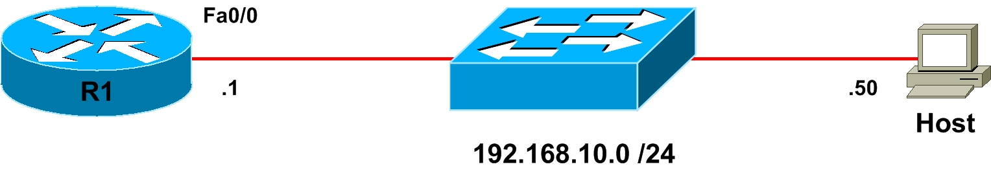

Scenario
In this lab, you will prepare a router for access via the Cisco Security Device Manager (SDM), using some basic commands, to allow connectivity from the SDM to the router. You will then install the SDM application locally on a host computer. Finally, you will install SDM onto the flash memory of a router.

Step 1: Preparation
Start this lab by erasing any previous configurations and reloading your devices. Once your devices are reloaded, set the appropriate hostnames. Ensure that the switch is set up so that both the router and host are in the same VLAN. By default, all ports on the switch are assigned to VLAN 1.
Ensure that your PC meets the minimum requirements to support SDM. SDM can be run on a PC running any of the following operating systems:
- Microsoft Windows ME
- Microsoft Windows NT 4.0 Workstation with Service Pack 4
- Microsoft Windows XP Professional
- Microsoft Windows 2003 Server (Standard Edition)
- Microsoft Windows 2000 Professional with Service Pack 4
Note: Windows 2000 Advanced Server is not supported.
In addition, a web browser with SUN JRE 1.4 or later or an ActiveX controlled browser must be enabled.

Step 2: Prepare the Router for SDM
First, create a username and password on the router for SDM to use. This login will need to have a privilege level of 15 so that SDM can change configuration settings on the router.

R1(config)# username ciscosdm privilege 15 password 0 ciscosdm
HTTP access to the router must be configured for SDM to work. If your image supports it (you will need to have an IOS image that supports crypto functionality), you should also enable secure HTTPS access using the ip http secure-server command. Enabling HTTPS generates some output about RSA encryption keys. This is normal. Also, make sure the HTTP server uses the local database for authentication purposes.

R1(config)# ip http server
R1(config)# ip http secure-server
% Generating 1024 bit RSA keys, keys will be non-exportable...[OK]
*Jan 14 20:19:45.310: %SSH-5-ENABLED: SSH 1.99 has been enabled
*Jan 14 20:19:46.406: %PKI-4-NOAUTOSAVE: Configuration was modified. Issue "write memory" to save new certificate
R1(config)# ip http authentication local
Finally, configure the virtual terminal lines of the router to authenticate using the local authentication database. Allow virtual terminal input through both telnet and SSH.

R1(config)# line vty 0 4
R1(config-line)# login local
R1(config-line)# transport input telnet ssh

Step 3: Configure Addressing
Configure the Fast Ethernet interface on the router with the IP address shown in the diagram. If you have already configured the correct IP address, skip this step.

R1(config)# interface fastethernet0/0
R1(config-if)# ip address 192.168.10.1 255.255.255.0
R1(config-if)# no shutdown
Next, assign an IP address to the PC. If the PC already has an IP address in the same subnet as the router, you may skip this step.
From the PC ping the R1 Ethernet interface. You should receive responses. If you do not receive a response, troubleshoot by verifying the VLAN of the switchports and the IP address and subnet mask on each of the devices attached to the switch.

Step 4: Extract SDM on the Host
Now that the router is ready to be accessed from SDM and there is connectivity between the router and the PC, you can use SDM to configure the router. You should start by extracting the SDM zip file to a directory on your hard drive. In this example, the directory used is “C:\sdm\,” although you can use any path you want.
You are almost ready to use SDM to configure the router. The last step is installing the SDM application on the PC.

Step 5: Install SDM on the PC
Double-click the setup.exe executable program to open the installation wizard. Once the installation wizard screen opens, click Next. Accept the terms of the license agreement, and then click Next.
The next screen prompts you to choose from three options where you want to install SDM.
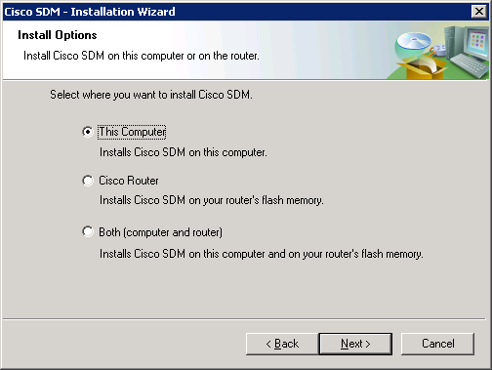
When installing SDM, you can install the application on the computer and not place it on the flash memory of the router, or you can install it on the router without affecting the computer, or you can install it to both. Both installation types are very similar. If you do not want to install SDM to your computer, skip to Step 7.
For now, click This Computer, and then click Next. Use the default destination folder and click Next again.
Click Install to begin the installation.
The software installs, and then you are prompted with a final dialog box to launch SDM. Check the Launch Cisco SDM box, and then click Finish.

Step 6: Run SDM from the PC
SDM should start up from the installer when you have completed step 5 if you checked the Launch Cisco SDM option. If you did not, or you are running SDM without just installing it, click the icon on the desktop labeled Cisco SDM. The SDM Launcher dialog box will open. Type the IP address of the router shown in the diagram as a Device IP Address. Check This device has HTTPS enabled and I want to use it if you enabled the HTTP secure server in step 2. Then click the Launch button.
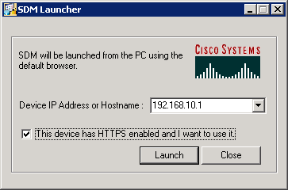
Click Yes when the security warning appears. Note that Internet Explorer may block SDM at first, and you will need to allow it or adjust your Internet Explorer security settings accordingly to use it. Depending on the version of Internet Explorer you are running, one of these settings is especially important for running SDM locally, and it is on the Tools menu, under Internet Options.... Click the Advanced tab, and under the Security heading, check Allow active content to be run in files on My Computer if it is not already checked.
Enter in the username and password you created earlier.
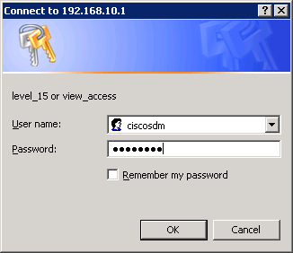
You may be prompted to accept a certificate from this router. Accept the certificate to proceed. After this, give the username and password for the router and click Yes.

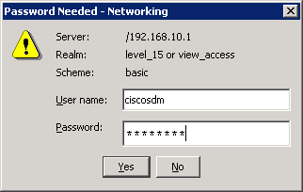
SDM reads the configuration off the router. If everything was configured correctly, you will be able to access the SDM dashboard. If your configuration here looks correct, it means you have successfully configured and connected to SDM. Your information may vary depending upon which version of SDM you are running.
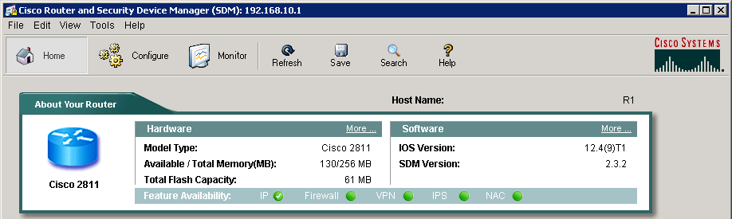

Step 7: Install SDM to the Router
Follow Step 6 until the prompt shown in the following figure appears. When this window appears, click Cisco Router to install SDM to your router’s flash memory. If you don’t want to install SDM to your router’s flash memory, or do not have the available space on the flash drive, then do not attempt to install SDM to the router.
Enter your router’s information so that the installer can remotely access and install SDM to the router.
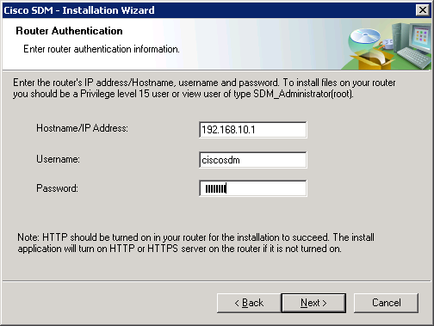
Cisco SDM connects to the router. You may notice some messages being logged to the console. This is normal.

Jan 14 16:15:26.367: %SYS-5-CONFIG_I: Configured from console by ciscosdm on vty0 (192.168.10.50)
Choose Typical as your installation type, and then click Next. Leave the default installation options checked and click Next.
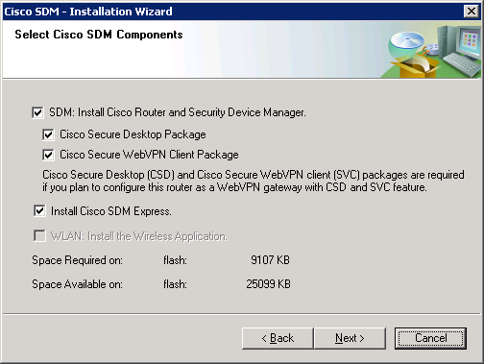
Finally, click Install for the installation process to begin. During the installation, more messages may be logged to the console. This installation process takes a little while (look at the timestamps in the console output below to estimate the duration on a Cisco 2811). The time will vary by router model.

Jan 14 16:19:40.795: %SYS-5-CONFIG_I: Configured from console by ciscosdm on vty0 (192.168.10.50)
At the end of the installation, you are prompted to launch SDM on the router. Before you do this, go onto the console and issue the show flash: command. Notice all the files that SDM installed to flash. Before the installation, the only file listed was the first file, the IOS image.

R1# show flash:

CompactFlash directory:
File Length Name/status
1 38523272 c2800nm-advipservicesk9-mz.124-9.T1.bin
2 1038 home.shtml
3 1823 sdmconfig-2811.cfg
4 102400 home.tar
5 491213 128MB.sdf
6 1053184 common.tar
7 4753408 sdm.tar
8 1684577 securedesktop-ios-3.1.1.27-k9.pkg
9 398305 sslclient-win-1.1.0.154.pkg
10 839680 es.tar
[47849552 bytes used, 16375724 available, 64225276 total]
62720K bytes of ATA CompactFlash (Read/Write)

Step 8: Run SDM from the Router
Open Internet Explorer and navigate to the URL “https://<IP address>/” or “http://<IP address>/” depending on whether you enabled the HTTP secure server in step 2. When you are prompted to accept the certificate, click Yes.
Ignore the security warnings and click Run.
Enter the username and password you configured in step 2.
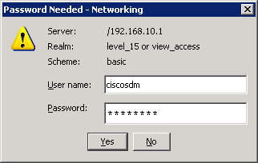
SDM will read the configuration off the router.
Once SDM is finished loading the current configuration of your router, the SDM homepage appears. If your configuration here looks correct, it means you have successfully configured and connected to SDM. What you see may differ from what appears in the following figure depending upon router model number, IOS version, and so forth.
